


Fully Automatic Exercise book Production line

Model: AFPS-1020B


Equipped with

Flexo Cylinder | 4 Pcs | Rotary Up / down Knife | 1 SET
Feeding Belt | 25 mts | Horizontal Up Knife (W18A ) | 1 Pc
Belt Lacing Machine | 1 Pc | Vertical upper Knife | 5 Pcs
Sheet counting gear | 4 pcs | Vertical Down Knife | 5 Pcs


Specification:
Max. paper roll dia. | 1200mm
Printing Width | Max.1020mm, min.680mm
Printing-Cutting Length | Max.430mm, Min.290mm
in steps of gear | 5mm
Max.size of notebook | 297*210mm
Min. Size of notebook | 160 x 125 mm
Printing color: | 2+2 ( 2 colour on both side)
machine Speed: | Max.280m/min(Running speed based on the paper thickness)
Inner sheet thickness: | 55g/㎡-120g/㎡
Number of sheet per groups: | 5-50 sheets, after folding 10-100 sheets
Qyt of stitching heads | 8 pcs
Max. number of notebook block | Max. 4 ups
Cover thickness: | 150g-450g
Max. cover pile height | 800mm
Notebook thickness: | 10mm ( unfolding book thickness:5mm )
Article thicnkess ( unfolded ) | 5mm
Max. output frequency | 45 times
Total power: | 22kw 380V 3phase (depend on your country's voltage)
Machine dimension: | L21.8m*W2.5m*H2.4m

Productiuon Flow Chart

1, | Single Reel stand | 8, | Stitcher (8 pcs stitching heads)
2, | Flexo ruling | 9, | Folding unit
3, | cross cutting | 10, | Spine Squared
4, | Sheet overlapping | 11, | Frontal trimming section
5, | Sheet Counting | 12, | Splitting and side trimming knives (5 pcs)
6, | 1st Cover inserter | 13, | Delivery table
7, | 2nd cover inserter

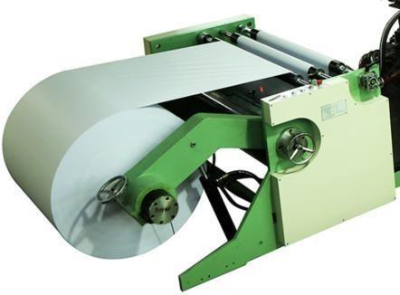
Descriptions

Single reel stand

- Unwind unit, Clamping chuck: 3"
- paper decurling system
- hydraulic pressure brake

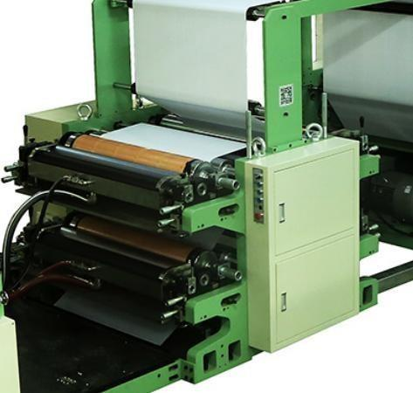
Flexo ruling unit for 2C+2C

- For integration of ruling units
- Printing stack frame uses 75 mm thickness cast-iron
_ 1 x ruling tower for 4 pcs ruling inkers equipped with 4 x transverse inker for ruling cylinders
4 x metal anilox rollers
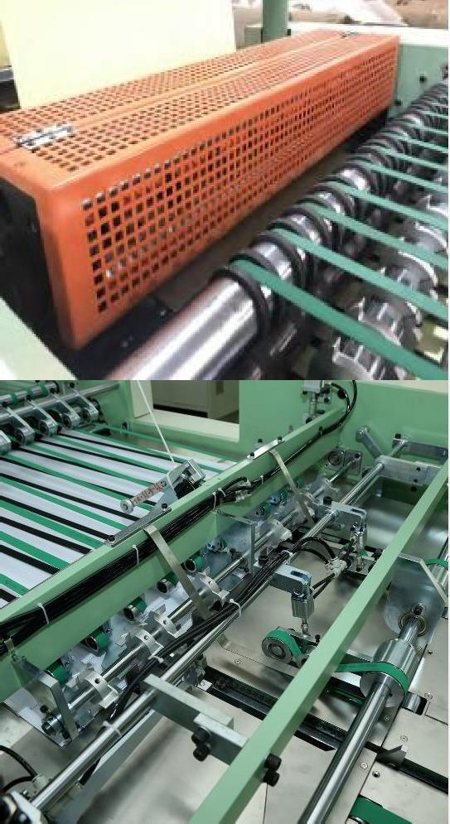
2 x ink trays for 2 colors ink.

Cross cutting
The rotary sheeter is maded from high speed steel blade for long lasting cutting
1 x set of rotary cutting system.

Overlapping, collecting and Counting
Sheet overlapping device
Sheet counting is controlled by counting gear. Sheet count to be specified by customer.

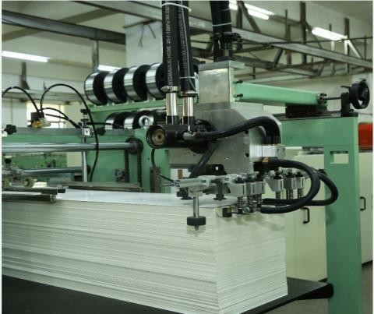

Cover inserter

The auto cover feeder are fully controlled by sensor for missed feed and minimize wastage.
Stack height is 800mm

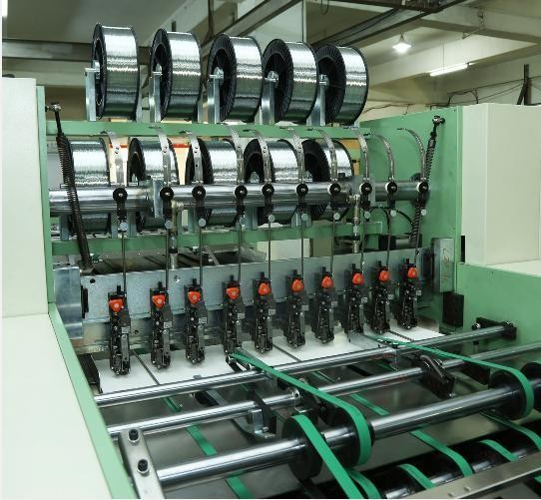

Stitching unit
8 x Germany Hohner 43/6 stitching head,
8 x wire coil holder ( wire coil weight is 15 kgs ) stitching Heads are driven by the transmission shaft

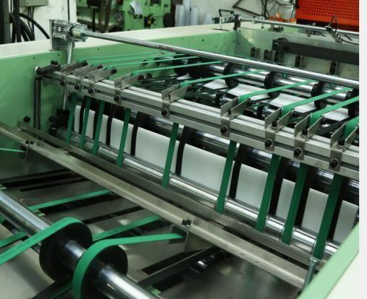
olding Part
F
1
x fold unit to center fold stitched book trips.

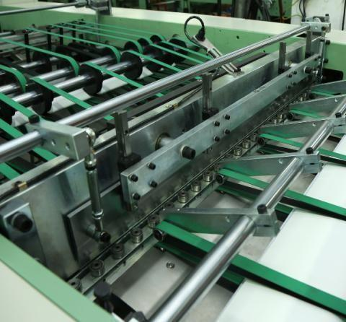
Spine Squared
Used mechanical cam and pressure spring to square the book back from the back .Easy to operate, no need to adjust to produce thin and thick books.


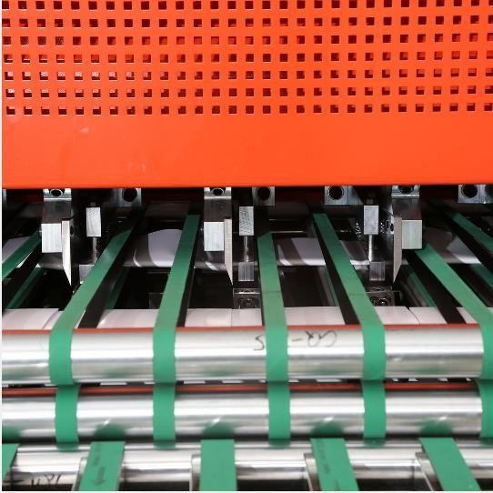
Trimming unit

Use 60mm thickness board,make the frame more solid.Use cast-iron material to
make the frame, make sure the cutting blade is stable, the unit will do a first face trim then with 2 sides, and 3th, 4th and 5th trim.
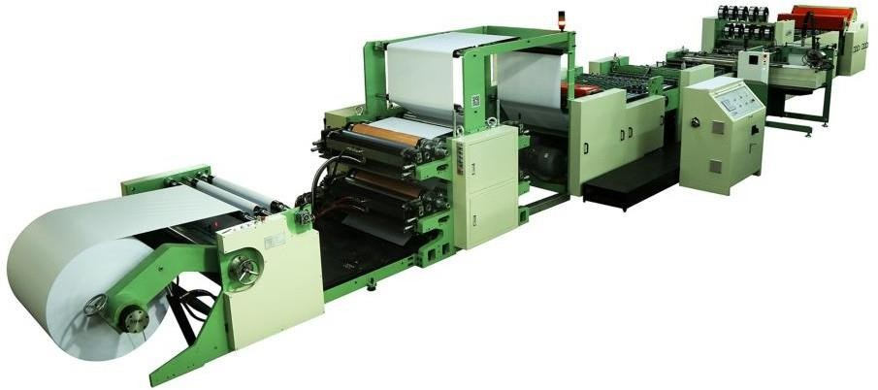
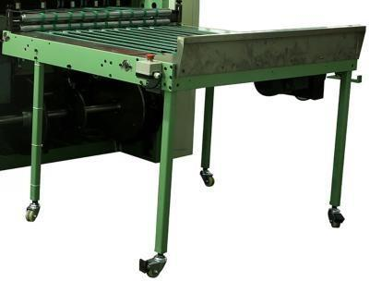
Finished product colletcing table

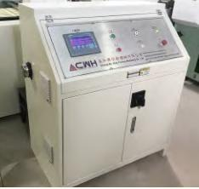
Electrical Components
All main electrical and electronic component are internationally CE approved brand such as Siemens and Schnieder.
Raw material for machine
Reel paper Stitching wire
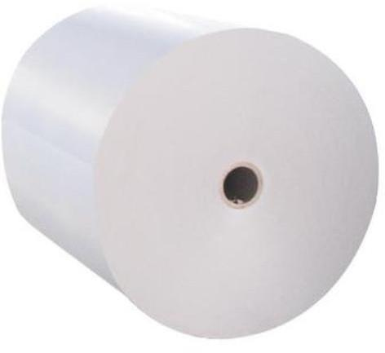
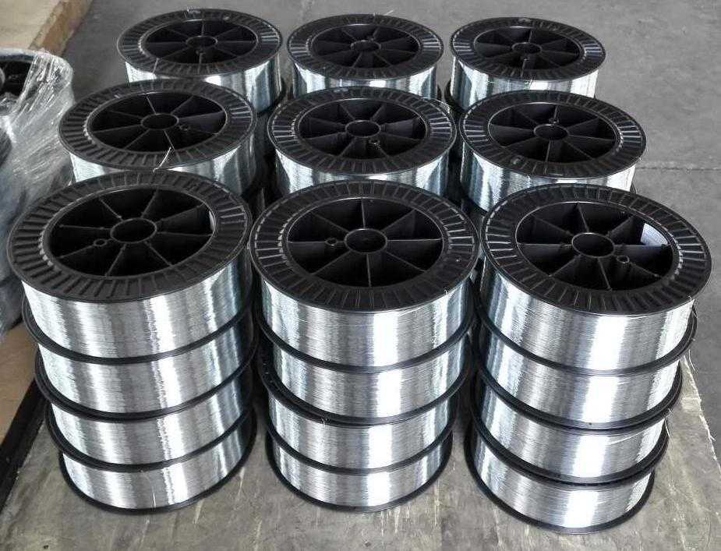

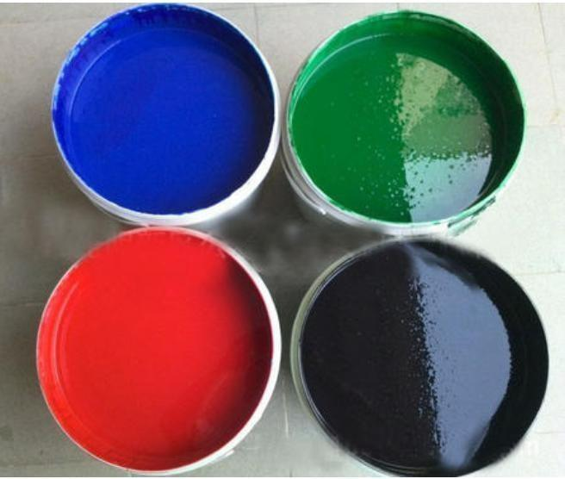
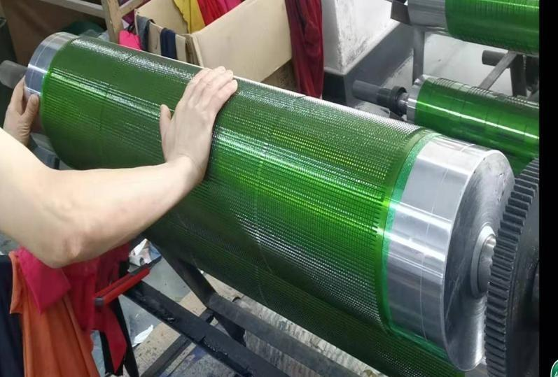
Water based ink ruling design plate
